ecTA – Time & Attendance Management System – Online roster input interface

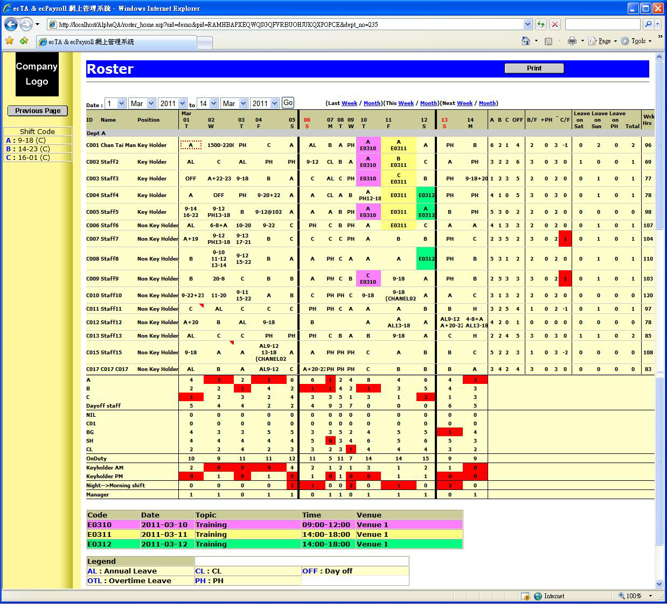
Last update : 2011/3/25

